31.41: a) If the original voltage was lagging the circuit current, the addition of an inductor will help it “catch up,” since a pure LR circuit would have the voltage leading. This will increase the power factor, because it is largest when the current and voltage are in phase.
b) Since the voltage is lagging, the impedance is dominated by a capacitive element so we need an inductor such that 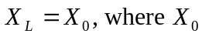 is the original capacitively dominated reactance (this could include inductors, but the capacitors “win”).
